8.67: a) The ratio of the kinetic energy of the Nash to that of the Packard is 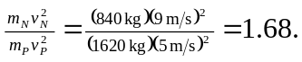 b) The ratio of the momentum of the Nash to that of the Packard is 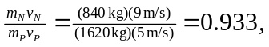 therefore the Packard has the greater magnitude of momentum. c) The force necessary to stop an object with momentum P in time t is  =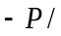t. Since the Packard has the greater momentum, it will require the greater force to stop it. The ratio is the same since the time is the same, therefore 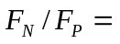 0.933. d) By the work-kinetic energy theorem, 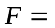 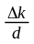. Therefore, since the Nash has the greater kinetic energy, it will require the greater force to stop it in a given distance. Since the distance is the same, the ratio of the forces is the same as that of the kinetic energies, 1.68.

